**ROC company analysis**

**Abstract:**

The project aims to leverage Artificial Intelligence (AI) for comprehensive exploration and predictive analysis of trends in company registrations, utilizing data from the Registrar of Companies (RoC). This endeavor encompasses a multifaceted approach involving data processing, machine learning modeling, and user interaction.

In an era marked by dynamic economic landscapes and evolving business ecosystems, the ability to discern and anticipate trends in company registrations is of paramount importance. Harnessing the power of Artificial Intelligence (AI) in tandem with data from the Registrar of Companies (RoC), this project endeavors to provide invaluable insights into the trajectories of corporate registrations.

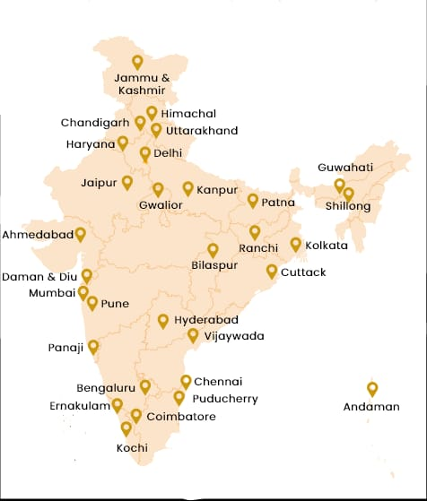

**Introduction:**

**Background:**

The Registrar of Companies serves as a repository of vital information pertaining to businesses, capturing their inception, industry affiliations, and geographic dispersion. By delving into this wealth of data, we aim to unearth patterns, anomalies, and emerging tendencies in company registrations. Through the application of advanced AI techniques, we endeavor to not only analyze historical trends but also forecast future developments.

**Objectives:**

The primary objectives of this project are twofold. Firstly, we seek to conduct a comprehensive exploratory analysis of historical company registrations, shedding light on pivotal factors influencing registration trends. Secondly, we endeavor to deploy cutting-edge AI models to provide accurate and reliable predictions of future registrations, thus empowering stakeholders with foresight for informed decision-making.

**Key Components:**

**Data Integration and Cleaning:**

The project commences with the assimilation of data from the RoC. This raw data undergoes rigorous processing to ensure integrity, completeness, and consistency, laying the foundation for robust analysis.

**Exploratory Data Analysis (EDA):**

Through EDA, we unravel the underlying dynamics within the dataset. Descriptive statistics, data visualization, and clustering techniques are employed to extract meaningful insights from the historical records.

**AI-Driven Predictive Modeling:**

Employing state-of-the-art machine learning algorithms, we construct models capable of forecasting company registration trends. These models are honed through iterative training and validation processes, culminating in accurate predictive capabilities.

**User Interaction and Customization:**

A user-friendly interface is developed to facilitate seamless interaction with the predictions. Users are empowered to tailor queries, filter results, and visualize trends, ensuring a personalized and intuitive experience.

**Significance:**

The outcomes of this project hold profound implications for a diverse spectrum of stakeholders. Investors can leverage the insights to make informed decisions, allocating resources judiciously. Policymakers gain a nuanced understanding of economic dynamics, enabling them to formulate targeted strategies. Market analysts glean valuable intelligence for strategic planning, while businesses themselves stand to benefit from the ability to align their operations with prevailing market trends.

**Conclusion:**

In amalgamating the analytical prowess of AI with the rich repository of the Registrar of Companies, this project aspires to be a beacon of foresight in the realm of corporate registrations. By deciphering the past and envisioning the future, we equip stakeholders with a powerful toolset for navigating the intricate landscapes of modern commerce.